2018

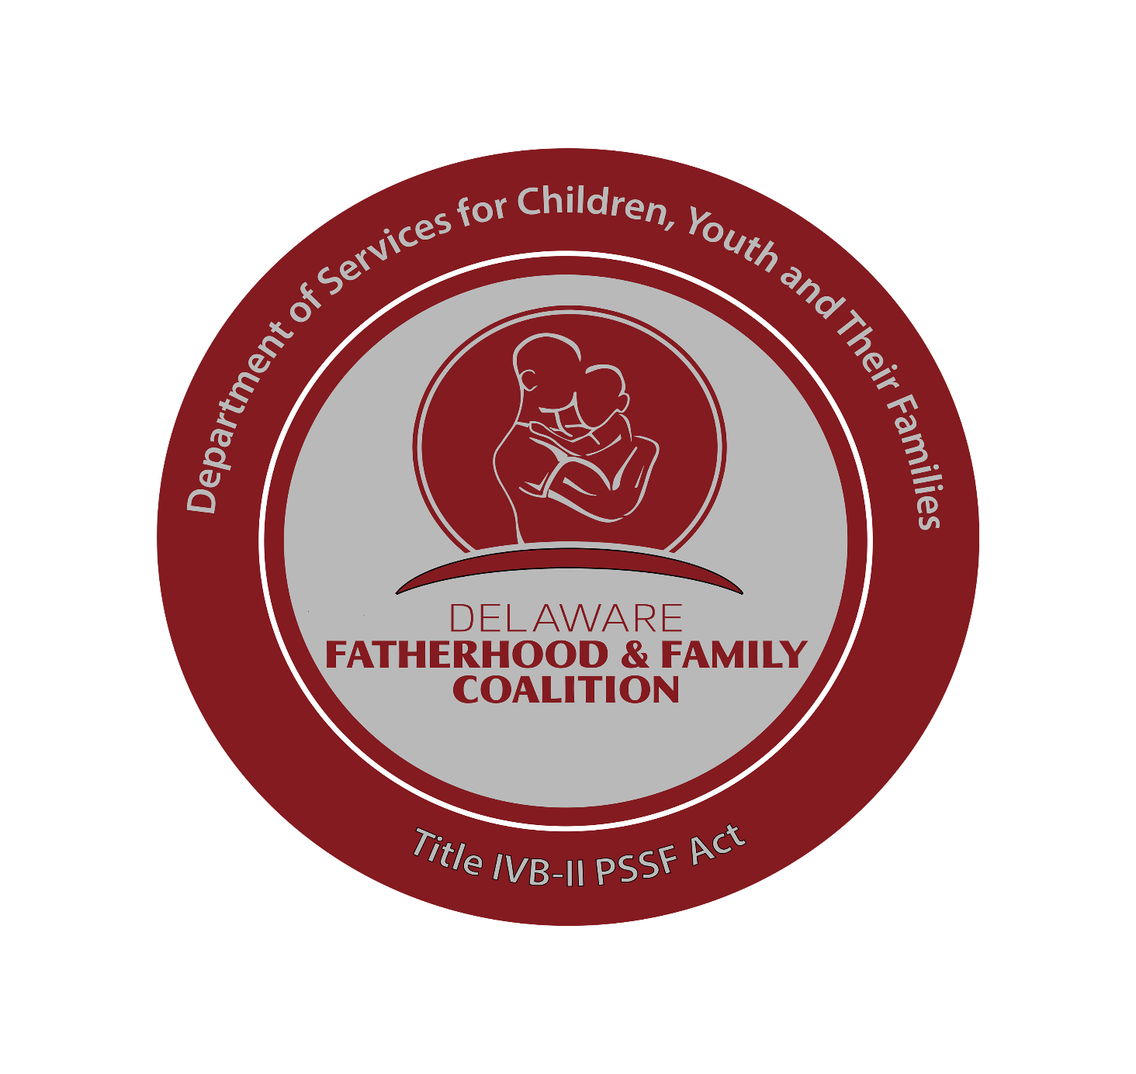­­

ELECTION PACKET

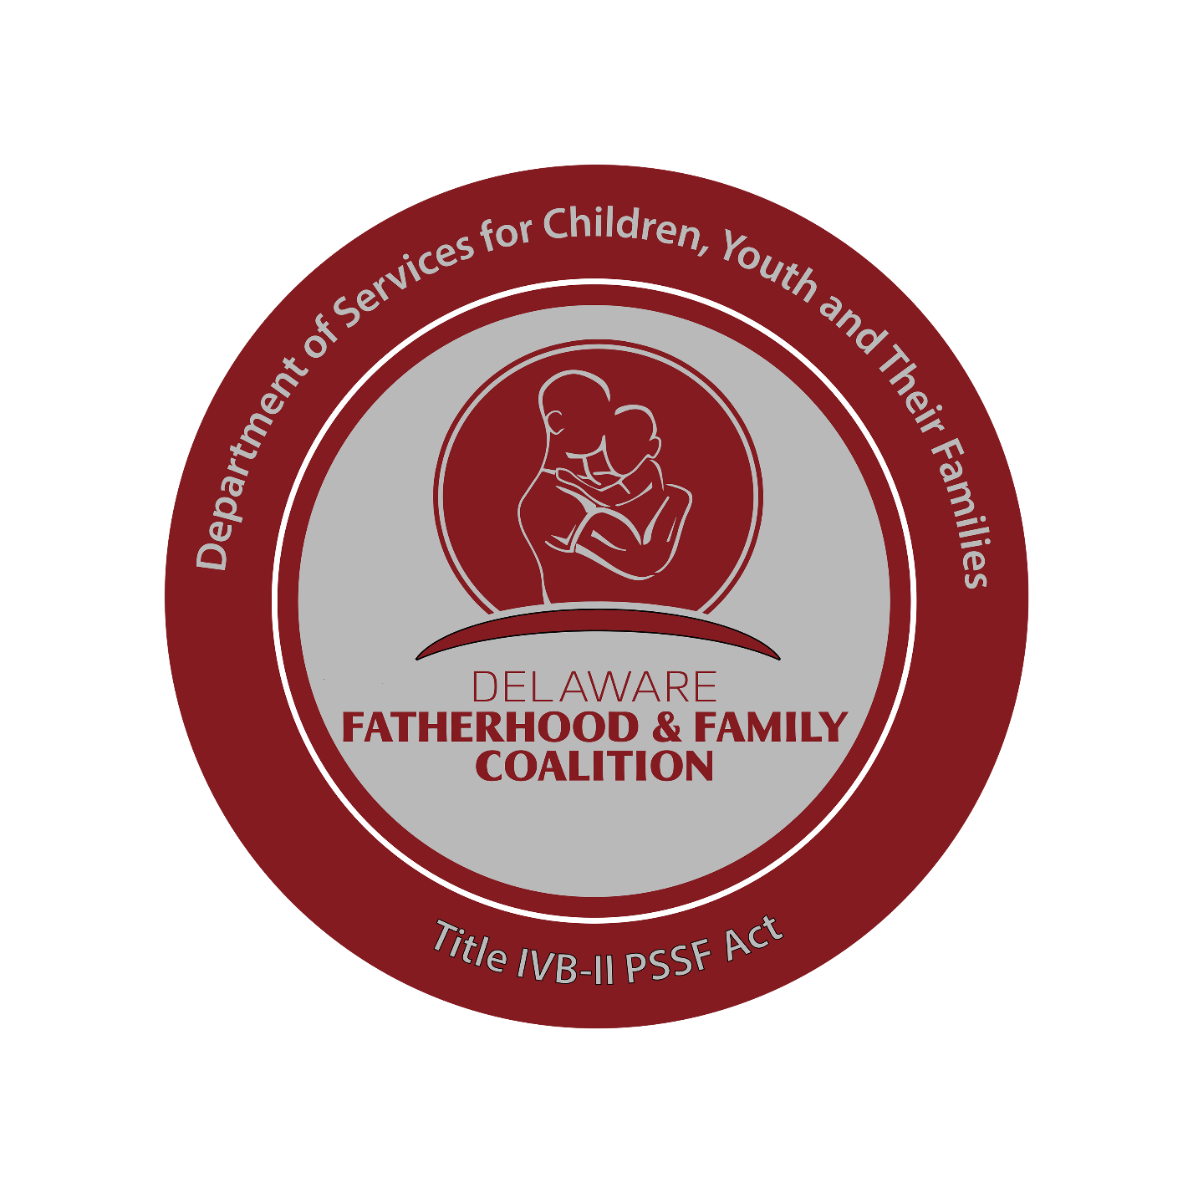**Delaware Fatherhood and Family Coalition**

New Castle County Leadership

**Application**

The Delaware Fatherhood and Family Coalition County Leadership applications are now open for the position(s): i.e. *President*, *Vice President* and *Recording Secretary* are open in New Castle County, Kent and Sussex Counties. If you are interested in serving the fathers, families and children of Delaware in a leadership position of the Delaware Fatherhood and Family Coalition please submit your application.

The Delaware Fatherhood and Family Coalition’s Community Leadership Coalition Election timeline is as follows:

* Applications returned **08/31/2018**
* **Reviewed**: Delaware Fatherhood and Family Coalition (DFFC) Statewide Coordinator **09/10/2018**
* Nominations Presented: **09/14/2018**
* Community Leadership Coalition Announced: **09/22/2018**
* Community Leadership Coalition: **10/01/2018**: (2) YRS
* Community Leadership Coalition Retreat: **10/27/2018**

**Delaware Fatherhood and Family Coalition**

New Castle County Leadership

**Application**

**Vision**

The Delaware Fatherhood and Family Coalition envisions healthy and resilient Delaware children whose fathers are involved, and parents effectively work together.

**Overview**

The Delaware Fatherhood and Family Coalition (**DFFC**) is an extension of the Promoting Safe and Stable Families Program and the Responsible Fatherhood Initiative created specifically to give a voice to fathers and the importance of their involvement for the well-being of their children. We believe in the power of fatherhood and non-violent, stable families where the safety of children and other family members is not at risk.

The Delaware Fatherhood and Family Coalition (**DFFC**) is an *Advocacy* and *Capacity-Building**Coalition*with a diverse and unified membership. The Delaware Fatherhood and Family Coalition (**DFFC**) infrastructure was created to develop platforms to address social barriers and challenges that prevent fathers from being involved in raising their children). The membership is made up of parents, community leaders, grass-root, service, state, interfaith and community-based organizations. The coalition actively collaborates, continuously develops partnerships, increases awareness, trains, educates, and builds the capacity of its members to promote the Delaware Fatherhood and Family Coalition (**DFFC**) mission.

**Delaware Fatherhood and Family Coalition**

New Castle County Leadership

**Application**

**Mission**

As a united *change agent*, we are committed to building a sustainable community coalition that champions father involvement and supports Healthy Adult Relationships; specifically, effective co-parenting. This in turn provides positive outcomes for Delaware children and communities.

**Purpose**

The Delaware Fatherhood and Family Coalition (**DFFC**) builds upon the efforts of the community to increase community collaboration and strengthen resources which support the involvement of fathers in the lives of their children, promotes effective co-parenting, and decreases the barriers that may challenge these efforts.

**Delaware Fatherhood and Families Coalition**

County Leadership Coalition **President**

**Roles and Responsibilities**

**Agreement**

I, __________________________ agree to fully perform the following roles and responsibilities as the ___________________ County **President** of Delaware Fatherhood and Family Coalition:

1. Chairs (Facilitates) County Leadership Coalition (**CLC**) monthly meetings.
2. Provide direct leadership and guidance in the operation of the County Leadership Coalition (**CLC**) in accordance Delaware Fatherhood and Family Coalition’s established *Guidelines, Protocols, Procedures* and *Code of Conduct*.
3. Nurture and support cohesive relations among the County Leadership Coalition (**CLC**) membership.
4. Attend, in person or by phone, **10** of **12** County leadership monthly County Leadership Coalition (**CLC**) meetings.
5. Conduct monthly County Leadership Coalition (**CLC**) executive leadership coalition meetings.
6. Support by attending **3** out of **4** County Leadership Committee sponsored events.
7. Represents County at Delaware Fatherhood and Family Coalition Statewide Leadership meetings.
8. As requested, attend in person or by phone, **85**% of Delaware Fatherhood and Family Coalition Statewide Leadership meetings.
9. Spokesperson/lead ambassador on behalf of coalition at local meetings, community presentation and events.
10. As a lead county ambassador identifies, collaborates and establishes community, agencies/organizational affiliation with the Delaware Fatherhood and Family Coalition and the County Leadership Committee.
11. Refer all traditional and social media inquiries to the Delaware Fatherhood and Family Coalition Communication Coordinator.
12. Chairs County Membership Committee – leading a team of local Delaware Fatherhood and Family Coalition County Leadership Coalition (**CLC**) members in planning and implementing activities that will engage, inform, activate, and grow membership in the respective county.
13. In the event of resignation and request to replace person in leadership position seeks recommendation of County Leadership Coalition (**CLC**) leaders/committee members of possible replacement. Consult with the Delaware Fatherhood and Family Coalition Guiding Team regarding the position recommended replacement.
14. The County Leadership Coalition (**CLC**) president is responsible to uphold and ensure the compliance of the Delaware Fatherhood and Family Coalition code of conduct and the technology policies are carried out.

**Term of Service:**

* 2 Year Term

**Dissolution Guidance:**

* If you are not able to complete your term as County Leadership Coalition (**CLC**) **President** for any reason: i.e. *Professional* or *Personal*; we request that you submit a thirty (**30**) written notice.

**Delaware Fatherhood and Families Coalition**

County Leadership Coalition **Vice-President**

**Roles and Responsibilities**

**Agreement**

I, __________________________ agree to fully perform the following roles and responsibilities as the ___________________ County **Vice-President** of Delaware Fatherhood and Family Coalition:

1. Chairs (Facilitates) County Leadership Coalition (**CLC**) meetings when President is absent.
2. Attend **10** of the **12** County Leadership Committee meetings (in-person or by phone).
3. Chairs County Delaware Fatherhood and Fatherhood Coalition Training/Annual Summit/Recognition Award’s Committee-entails leading team of local Delaware Fatherhood and Family Coalition County Leadership members to participate in planning of Delaware Fatherhood and Family Coalition County Leadership Coalition (**CLC**) Training, *Annual Summit* and *Recognition Award Committee*.
4. Represents County or appoints designee to serve on Statewide Training and Technical Assistance Teams.
5. Support cohesive relations among the County Leadership Coalition (**CLC**) membership.
6. As A Delaware Fatherhood and Family Coalition ambassador identifies, recruit and engage County Leadership Coalition (**CLC**) members.
7. Refer all traditional and social media inquiries to the County Leadership Coalition (**CLC**) President who will defer to the Delaware Fatherhood and Family Coalition Communication Coordinator.
8. At the request of the County Leadership Coalition (**CLC**) President, services as County Representative at Delaware Fatherhood and Family Coalition Statewide Leadership meetings and or Community Presentations.
9. Uphold and adheres to the Delaware Fatherhood and Family Coalition *Code of Conduct and Technology* policy.
10. In the event of resignation by President, agrees to serve as interim President until office is filled in conjunction with the Delaware Fatherhood and Family Coalition County Leadership Committee and the Delaware Fatherhood and Family Coalition Steering Committee.

**Term of Service:**

* 2 Year Term

**Dissolution Guidance:**

* If you are not able to complete your term as County Leadership Coalition (**CLC**) **Vice** **President** for any reason: i.e. *Professional* or *Personal*; we request that you submit a thirty (**30**) written notice.

**Delaware Fatherhood and Families Coalition**

County Leadership Coalition **Recording Secretary**

**Roles and Responsibilities**

**Agreement**

I, __________________________ agree to fully perform the following roles and responsibilities as the ___________________ County **Recording Secretary** of Delaware Fatherhood and Family Coalition:

1. Maintains records of the Coalition County Leadership Coalition (**CLC**) and ensure effective management of the Coalition County Leadership Coalition (**CLC**) members records(*log*), monthly meetings and event summaries.
2. Manages minutes of the Coalition County Leadership Coalition (**CLC**) monthly meetings.
3. Upon approval by the Coalition County Leadership Coalition (**CLC**) President, ensure minutes are distributed to Coalition County Leadership Coalition (**CLC**) members and the Delaware Fatherhood and Family Coalition Communication Coordinator; within one (**1**) week from each meeting.
4. Responsible for coordinating with Coalition County Leadership Coalition (**CLC**) President to develop and distributing meeting agendas, managing correspondence and communications with County Delaware Fatherhood and Family Coalition members.
5. Coordinates sending County correspondence to Delaware Fatherhood and Family Coalition Communications Coordinator for *review* (**approval**) and *distribution* statewide.
6. Coordinate onsite membership signup on site of Delaware Fatherhood and Family Coalition County Leadership Coalition (**CLC**) exhibits and or sponsored events.
7. Maintains County specific membership roster.
8. Uphold and adhere to the Delaware Fatherhood and Family Coalition code of conduct and technology policy.
9. Refer all traditional and social media inquiries to Coalition County Leadership Coalition (**CLC**) President who will forward inquiries to the Delaware Fatherhood and Family Coalition Communication Coordinator.

**Term of Service:**

* 2 Year Term

**Dissolution Guidance:**

* If you are not able to complete your term as County Leadership Coalition (**CLC**) **Recording** **Secretary** for any reason: i.e. *Professional* or *Personal*; we request that you submit a thirty (**30**) written notice.

**Delaware Fatherhood and Families Coalition**

Contact Information

**First Name**: ______________________ **Last Name**: _______________________________

**E-Mail**: ______________________________________ **Phone**_______________________

**County**: New Castle ______ Kent_____ Sussex ______

**What Position are you seeking**?

President______ Vice-President_________ Recording Secretary_______

**Are you an active member of Delaware Fatherhood and Family Coalition**?

YES_____ NO_____

If **yes**, at what capacity of membership?

Active Member_________ Leadership Officer_________

If **yes** to **Leadership Officer**, at what capacity?

President______ Vice-President_________ Recording Secretary_______

**What attributes would you bring to the position of interest and to the coalition**?

_______________________________________________________________________________________________________________________________________________________________________________________________________________________________________________________________________________________________________________________________________________________________________________________________________________________________________________________________________________________________________________________________________________________________________________________________________________________________________________________________________________________________________________________________________________________________________________________________________________________________________________________________________________________________________________________________________________________________________________________________________________

**I have read and understand all position are volunteer.**

YES_____ NO_____

**Resume is enclosed.**

YES_____ NO_____

**Delaware Fatherhood and Family Coalition Leadership Application is completed and signed**?

YES_____ NO_____

**I will attend the Delaware Fatherhood and Family Coalition Leadership County Leadership Coalition meeting in my respective county to meet the membership**.

YES_____ NO_____

**Signature**_________________________ **Date**_______________________